IMPERIAL GUARD ALUMNAE SCHOLARSHIP APPLICATION
For Former Scholarship Winners
DEADLINE: March 8, 2024
Eligibility: one of the following
- Any former winner of the Imperial Guard Alumnae organization scholarship
- Enrolled in educational program
- Maintained a 3.0 on a 4.0 scale

The scholarship is made out to the institution upon verification of enrollment. Notification of the winner of the scholarship is in May.

Please type or legibly print the information to complete this application. Attach additional paper if needed.

PERSONAL INFORMATION:
Name: ___________________________________

Social Security Number (give upon notice of being awarded)
Accepting University ID: (give upon notice of being awarded)

Address for Mailing (include the zip): ___________________________________
__________________________________________________________________

Home Phone (include area code): ____________________________

Cell Phone: _______________________________
Email: _________________________________________

Emergency Contact Information: Name: ________________________________

Relationship: ___________________________ Phone: _____________________

You only need to fill this one sheet and send us a copy of your current transcript.

Any questions just email me at RCReibenstein@aol.com
Or you can call 713 725 1826

Thanks,
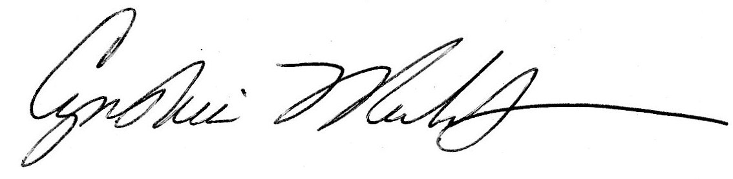
Cynthia F. Reibenstein, President Imperial Guard Alumnae

